
Name: _____________________

Pythagoras Theorem Investigation
Take Home Section

Year 9

Question 1

- Square the following numbers:  Eg: 4² = 16  6  148  5  29 | - Square root the following numbers:  Eg: $√2$ = 1.41  7  89  20  100

Question 2

The hypotenuse of a right triangle is always opposite the right angle. Label the line that is opposite the right angle.
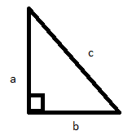

 |  | 

Question 3

Test whether each of the following triangles are right-angled triangles.
Example:
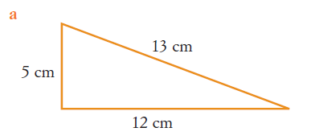
Step 1: Calculate the square of the longest side
13² = 169

Step 2: Calculate the squares of the other two sides and add them together.
5² + 12² = 25 + 144 = 169

Step 3: Apply the convers of Pythagoras’s Theorem.
5² + 12² = 13²
The triangle is a right-angled triangle because the square of the longest side is the sum of the squares of the other two sides

Complete the following:

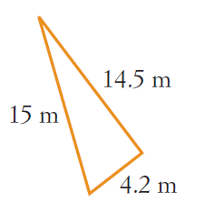
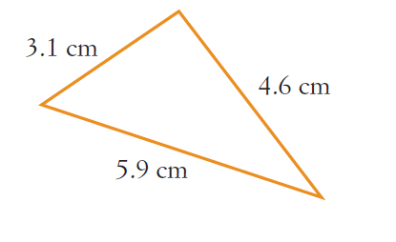

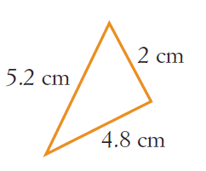

Question 4

To find the area of a circle we use this formula: $A=πr^{2}$

Find the area of the following circles:

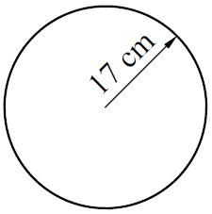 | 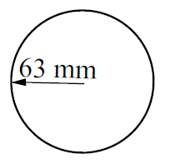 | 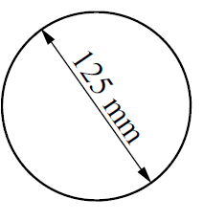

To find the area of a semi-circle you need to use the following formula: $A=\frac{1}{2}πr^{2}$

Find the area of the following semi-circles:

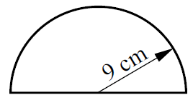 | 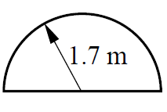 | 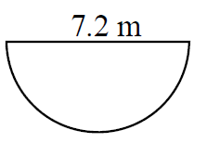

Question 5

Use Pythagoras Theorem to find the unknown sides of the right angle-triangles. Show all working out.

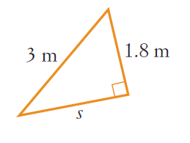 | 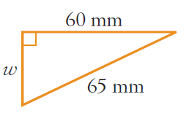
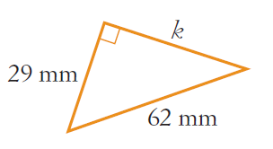 | 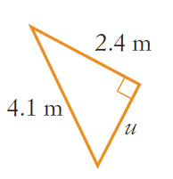

- A 2.3m ladder is resting against a wall as shown. If the foot of the ladder is 0.8m from the base of the wall, how far up the wall will the ladder reach?
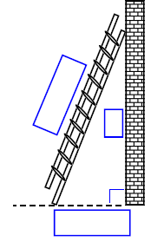
Step 1: Start by filing in the boxes:

Step 2: Use Pythagoras’s Theorem to solve the problem

End of Take Home Section

